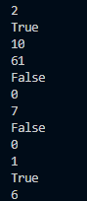

7 is the ‘siteID’ of Conistone Ave Shops.

False– indicating that the program has detected it has zero

0- indicating the number of entries it has is zero

2 for the ‘siteID’ of the location selected (in this case Beeston Street.

True – indicating that the program has detected it has entries currently

10- indicating the number of entries it has

Testing deleting a site with entries and a site without entries – Successful ^

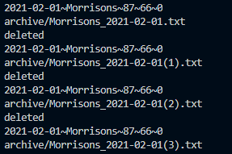

Testing that when a file is written with the same name as an existing one, a number is added – Successful ^



Testing archiving entries when a site is deleted. Files are created successfully ^

